Presenting the
Anniversary Thankoffering
To Your Congregation
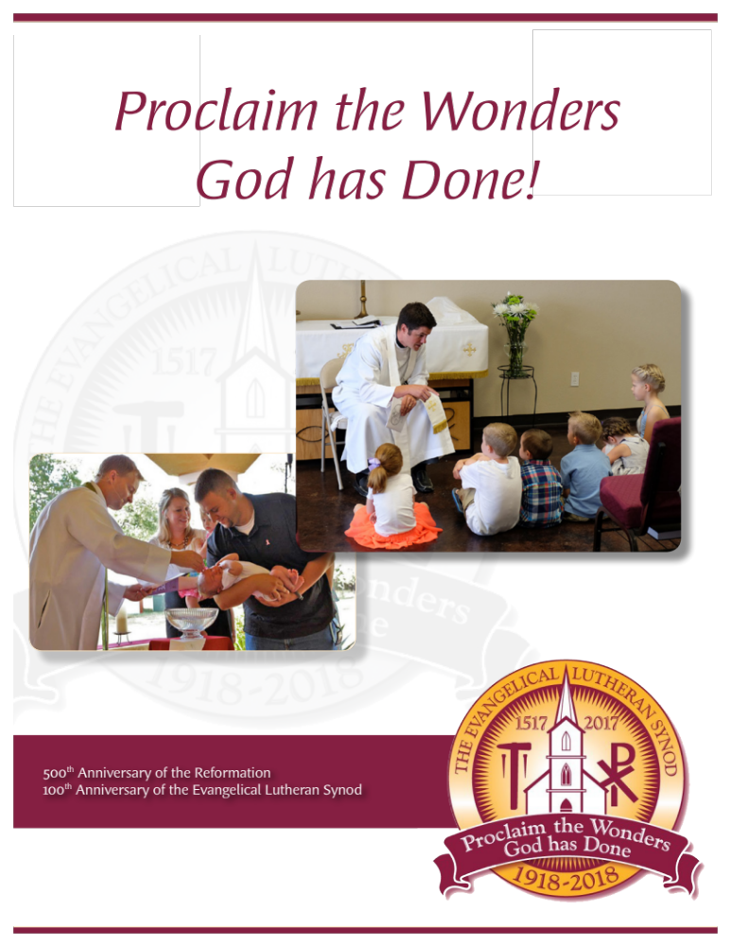
Overview of Materials and Information For Your Congregational Rollout
Pastors and Communicators

Visit our website at
els.org/offering
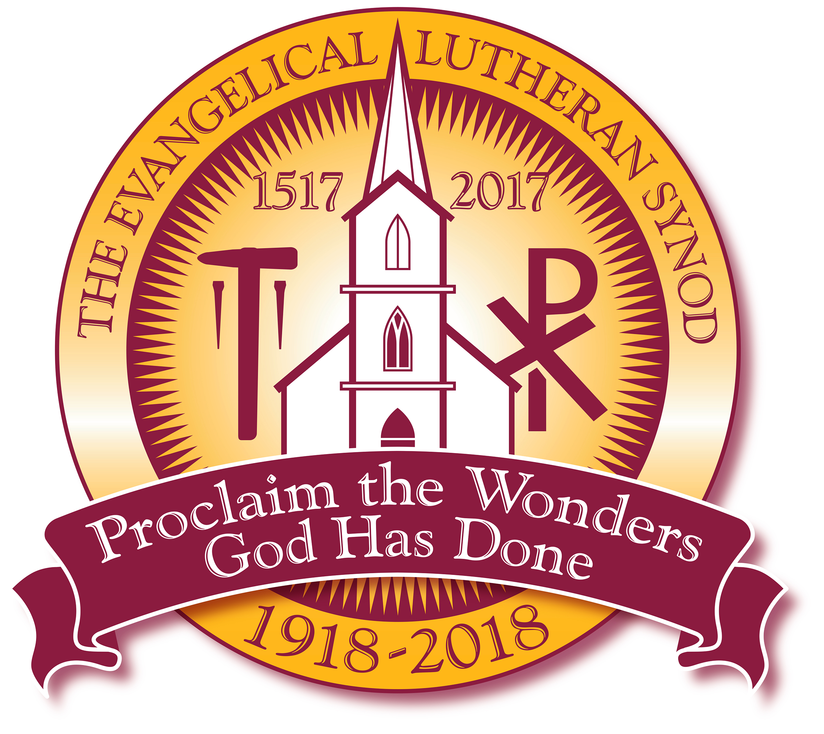
It contains everything you need
to make a presentation
of the ELS
Anniversary Thankoffering
to your congregation.

Call 507-344-7311
For more information or assistance in making your presentation.

Note: Committee members can help make presentations to your congregation upon request. (Available Speakers - First come first serve: Pastors D. Basel, M. Smith, T. Zenda, L. Wentzlaff, J. Moldstad, and our laymen, David Ewert and Dan Neumann.)
Presenting the
Anniversary Thankoffering
To Your Congregation

ENGAGING OUR CONGREGATIONS WITH THIS OFFERING
What are we asking you to do?
We are asking you, our fellow ELS members and congregations, to help carry our Reformation and ELS Lutheran heritage forward. We certainly do that in various ways. But we also encourage each other to further this heritage by supporting missions. With this celebration and offering, you, our delegates and pastors, in convention have chosen to support home missions under the theme, “Proclaim the Wonders God Has Done.”

Consider again the words of the hymn, God’s Word is Our Great Heritage,
“God’s Word is our great heritage and shall be ours forever.
To spread its light from age to age shall be our chief endeavor….” (ELH 583)
- As you choose your date for your congregation’s presentation… please consider using several Sundays this September to study both the Word of God and Christian stewardship as you present the offering materials.
  - The target dates will be the 17th, 18th and 19th Sundays after Pentecost (September 11th, 18th, and 25th). That’s 16th-18th after Trinity for many.
  - We would recommend that any single Sunday presentations be done September 25th or soon thereafter.
- Presentation Day
(If you study, understand, and share the information provided faithfully, there is no wrong way to do this. The key is your example as pastors and communicators. Your personal commitment and support of missions is key to a successful offering).
  - Present the offering booklet to your congregation.
  - Please use video on the presentation day.
    - Two ways to approach the presentation, 1) You can present the video on the third Sunday of the “Three-Sunday” stewardship/offering series.
    - Or, 2) present the booklet the first week and bring in cards and gifts over the next two weeks.
    - If you are only using one Sunday, present video and booklet and then remind members to bring in their gifts, promises and offerings over the new few weeks.
    - Do what works for your congregation (including the use of sermons and Bible studies).
- Gathering the Gifts:
  - Individual members can give a gift to their church for the offering.
  - Individuals can send in gifts directly to synod offering.
Each envelope is addressed. Place a stamp on the envelope and send it in. We will then send you a receipt.
  - Individuals and congregations can give at els.org/donate site.
You can give a one-time gift or set up recurring gifts from checking or your credit/debit. We’ll then send receipts.

- Your Proclaiming God’s Wonders Materials (Available at els.org/offering)
- An offering booklet for the families or individuals in your congregation outlining the purpose and mission project focus of the offering.
- Anniversary Offering Video (Under 7 minutes long) highlighting the offering and the importance of supporting our home missions program.
- Posters for church entries and bulletin board(s). Please use multiple posters if possible.
- Bulletin Inserts (four of them the first year) that highlight the offering and home mission work (Only two provided with convention materials).
- Introductory resources that include a congregational stewardship component as gifts and promises are considered.
1) Three sermons and themes adaptable to your preaching style and for your congregation
These follow the ILCW series C Gospel readings for the 17th -19th Sundays of Pentecost (with Evangelism, Stewardship, and Sola Scriptura as the main themes).
2) Three Bible Studies following these themes to help build the spiritual foundation for good stewardship in your congregation.
3) A stewardship page in the booklet to help your members calculate the proportional gifts we bring to our Lord, and then plan what to bring forward in thanksgiving for this offering.
4) A gift and/or promise page as well as an envelope to submit gifts.

- Other resources as the offering continues
Pastors/Communicators: Please be sure to bring these to everyone’s attention.
- E-Newsletters to highlight the offering and our home mission blessings around the synod. Printable versions can be made available.
- Lutheran Sentinel articles.
- Special support for your church in collecting the offerings. We can track promises or plans to give regularly and send reminders. We can also do all the bookkeeping regarding the offering here at the synod office.
- President Moldstad will continue to give regular reports in his newsletter on the progress of the offering as well as offer encouragement to give. The Graph published in the President’s Newsletter will then be updated on the website on a monthly basis.
- The synod convention essay entitled, “Proclaim the Wonders God Has Done: Give Thanks to His Name!”

Conclusion
God’s blessings as you seek to glorify our God in all you do. Be assured that our Anniversary Offering Committee (AOC) stands ready to assist you as you work in supporting missions in our synod. As we preserve and share our Lutheran Heritage may it also be our prayer, “God grant while worlds endure, we keep its teachings pure, throughout all generations” (ELH 583).
Pastor Dan Basel, Chairman
Anniversary Offering Committee
507-344-7311

